**Mandatory Hands-on Exercises**

1. **Singleton Pattern**

**Output-**

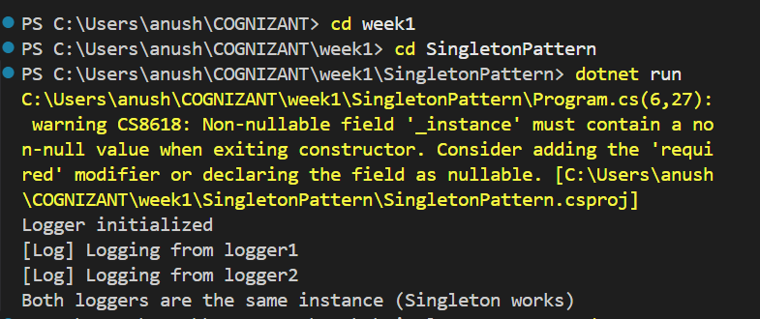

1. **Factory Method Pattern**

**Output-**

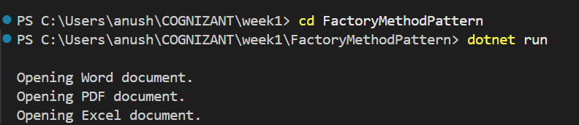

1. **Ecommerce Search Optimization**

**Ouput -**

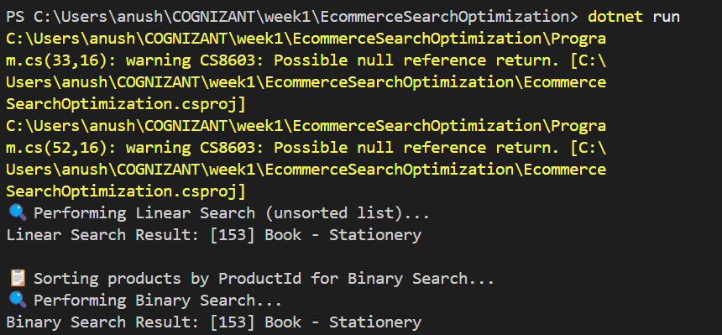

1. **Financial Forecasting**

**Outupt-**

